Q1. Create a dataframe of ten rows, four columns with random values.

Q2. Create a pandas series from each of the items below: (i) a list, (ii) numpy and (iii) a dictionary

Q3. Concatenate two data frames. Create two data frames using the following two dictionaries.

GermanCars = {'Company': ['Ford', 'Mercedes', 'BMV', 'Audi'], 'Price': [23845, 171995, 135925 , 71400]}

japaneseCars = {'Company': ['Toyota', 'Honda', 'Nissan', 'Mitsubishi '], 'Price': [29995, 23600, 61500 , 58900]}

Q4. Consider the given “Automobile_data” dataset

**Dataset link: https://siescms-my.sharepoint.com/:x:/g/personal/shyamalae_sies_edu_in/EW--Mp1hElFJh8zq4HFG-yMBOa6SFbcdAJCN-5t3bbAKgw**

1. From the given dataset print the first and last five rows
2. Clean the dataset and update the CSV file (i.e remove nan)
3. Write a Pandas program to detect missing values of a given DataFrame. Display True or False.
4. Write a Pandas program to drop the columns where at least one element is missing in a given DataFrame.
5. Write a Pandas program to count the number of missing values in each column of a given DataFrame.

Q5. For the given “company_sales_data” dataset

**Dataset link: https://siescms-my.sharepoint.com/:x:/g/personal/shyamalae_sies_edu_in/ESLXD8kVtolLmlh_scMf4XYBe9qcvJa9eGHFv62RipFclA**

1. Get total profit of all months and show line plot with the following Style properties. Generated line plot must include following Style properties: –

* Line Style dotted and Line-color should be red
* Show legend at the lower right location.
* X label name = Month Number
* Y label name = Sold units number
* Add a circle marker.
* Line marker color as read
* Line width should be 3

Sample o/p:

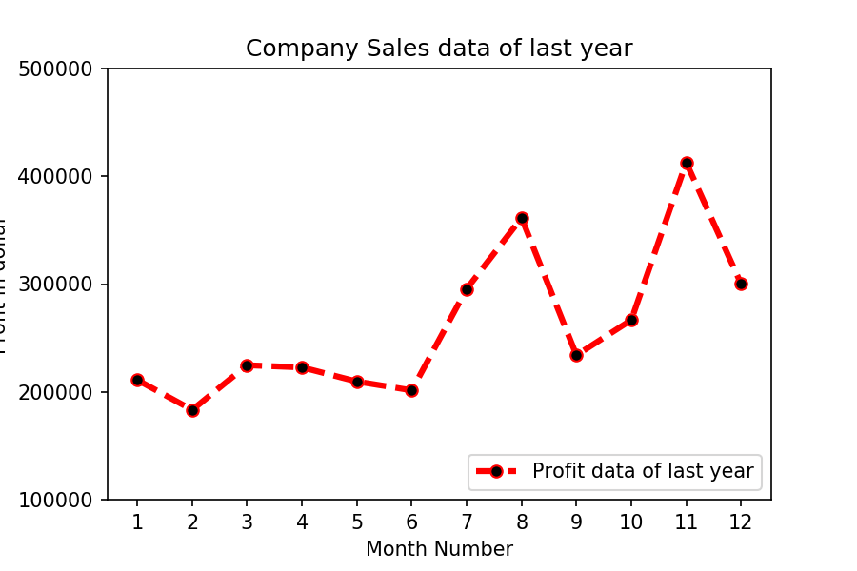

1. Read all product sales data and show it  using a multiline plot. Display the number of units sold per month for each product using multiline plots. (i.e., Separate Plotline for each product ).

Sample o/p:

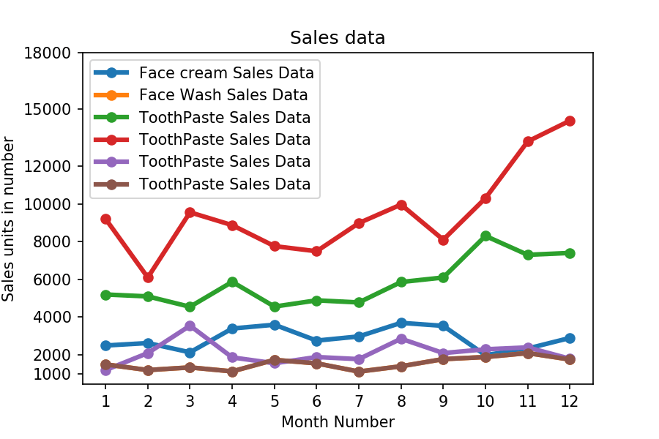

1. Read toothpaste sales data of each month and show it using a scatter plot

Sample o/p:

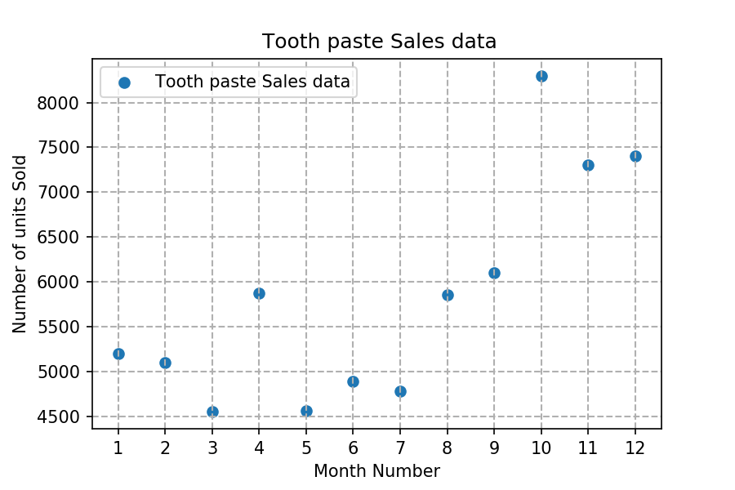

1. Read the total profit of each month and show it using the histogram to see the most common profit ranges

Sample o/p:

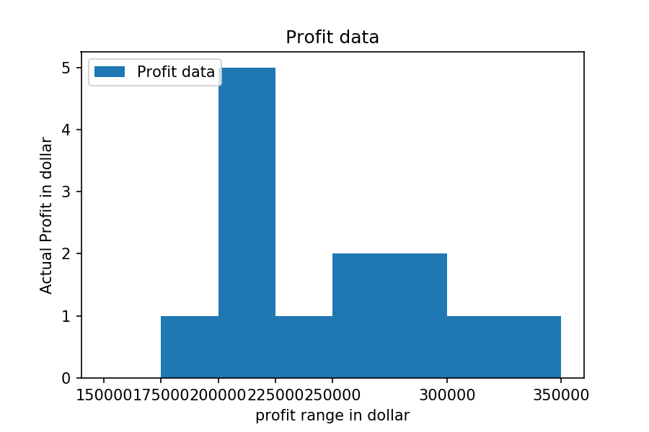

1. Calculate total sale data for last year for each product and show it using a Pie chart.

Sample o/p:

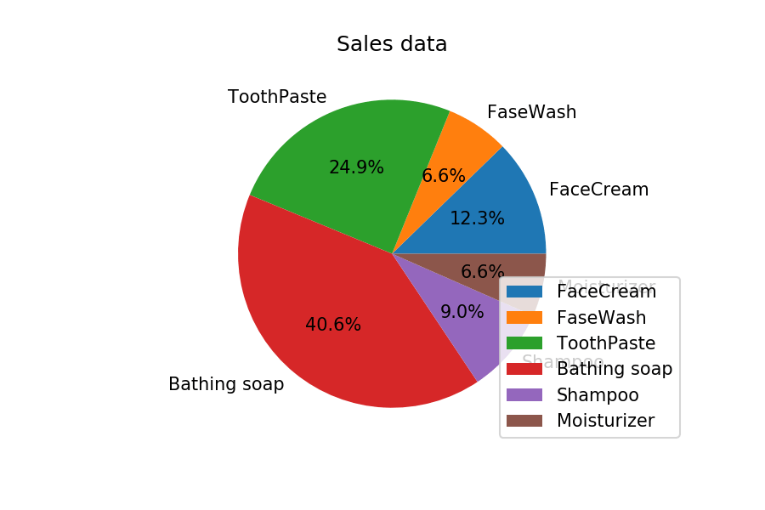

1. Read Bathing soap facewash of all months and display it using the Subplot

Sample o/p:

